

Software Engineering Department

Capstone Project – Phase A (61998)

Predictive Failure Detection in CT Systems

26-1-D-31

Students:
Anat Rutman
Iris Kanter

Advisor:
Dr. Reuven Cohen

Co-Advisor from Philips:
Michael Bikman

Link to GitHub:
https://github.com/anatrut/AI-Based-Analysis-and-Fault-Prediction-System-for-CT-Scanners-Project
Contents
Abstract 3
1. Introduction 4
1.1. Existing Solutions 5
1.2. Stakeholders 5
2. Literature Review 5
3. Expected Achievements: 7
3.1. Outcomes 7
3.2. Unique Features 7
3.2.1. Log-Based, Multimode Predictive Maintenance Engine 7
3.2.2. Hybrid Feature Learning from CT Event Logs 8
3.2.3. Integrated Fault Detection, Classification, and Failure Probability Estimation 8
3.2.4. Handling Class Imbalance and Rare Faults 9
3.2.5. Fleet-Level Analytics, Benchmarking, and Digital-Twin Capability 9
3.2.6. Explainability, Visualization, and Human-in-the-Loop Feedback 9
3.2.7. Methodological and Educational Contribution 10
4. Criteria for Success 10
4.1. Predictive Performance 10
4.2. Robustness and Generalization 11
4.3. Scalability, Maintainability, and Integration 11
4.4. Knowledge and Methodology Outcomes 11
5. Engineering Process 11
5.1. Process – Development Approach and Workflow 11
5.2. Overall Development Methodology 12
5.2.1. Problem and Stakeholder Analysis 12
5.2.2. Data Understanding and Acquisition 12
5.2.3. Data Preparation and Log Normalization 12
5.2.4. Multimode Operation Analysis 12
5.2.5. Feature Engineering and Sequence Representation 12
5.2.6. Modeling – Initial ML Baselines 13
5.2.7. Modeling – Advanced Sequence and Deep Learning Models 13
5.2.8. Evaluation and Error Analysis 13
5.2.9. Architecture and System Design 13
5.2.10. Prototype Implementation and Pilot 13
5.2.11. Iterative Refinement and Scaling 13
5.3. Work Completed So Far 13
5.3.1. Baseline Random Forest results 14
5.3.2. Planned Future Work 15
5.3.3. Constraints and Challenges 15
6. The Product 17
6.1. High level system architecture 17
6.2. Algorithms and Models 17
6.2.1. Log Parsing and Template Extraction 17
6.2.2. Feature Engineering and Time-Series Representation 18
6.2.3. Prediction Models 18
6.2.4. Targets and Outputs 19
6.2.5. Data Structures 19
6.2.5.1. Core Entities 19
6.3. User Interface – Conceptual Design 20
6.3.1. Main Dashboard 20
6.3.2. Scanner Detail View 20
6.4. Requirements 21
6.4.1. Functional 21
6.4.2. Non-functional 21
7. Diagrams 22
7.1. Use Case 22
7.2. Backend Activity Diagram 23
7.3. Frontend Activity Diagram 24
8. Verification and Evaluation 25
8.1. Verification 25
8.2. Evaluation 26
9. Terms 26
10. References 28

Abstract
This project focuses on developing a predictive maintenance system for Computed Tomography (CT) scanners using operational log analysis and machine learning. CT scanners generate extensive streams of time-stamped logs reflecting hardware state, calibration activity, environmental conditions, and software behavior. While these logs contain valuable diagnostic signals, their sheer volume and heterogeneity make manual interpretation ineffective, causing failures to be detected only once performance has already degraded. Current approaches such as threshold alerts or manual log inspection lack the ability to recognize subtle temporal patterns that preceded breakdowns, leading to unexpected downtime and costly service interventions.
The proposed system utilizes an automated pipeline that preprocesses raw logs, extracts behavioral features, and models temporal sequences using deep learning architectures including LSTM, Transformers, or autoencoder-based anomaly detection. By learning recurrent failure signatures across subsystems, the model aims to generate early-warning alerts hours or days before malfunction, while highlighting the most relevant contributing patterns.
This solution supports proactive maintenance for service engineers, provides R&D teams with insights into fault evolution, and improves availability for healthcare facilities. By combining log-driven analytics with modern deep learning methods, the project seeks to transform CT maintenance from reactive to proactive, reducing downtime and improving clinical workflow reliability.

Introduction
Modern CT scanners are complex electromechanical systems composed of hardware assemblies, integrated sensors, control software and real-time processing units. During routine operation, they continuously generate massive streams of time-stamped logs that document mechanical activity. For example, gantry rotation speed that refers to the speed that the CT’s rotating circular frame moves around the patient during image acquisition, and tube output, which indicates the radiation level generated by the X-ray tube etc. In addition, the logs documents calibration procedures, software events, error messages, environmental measurements and interactions among subsystems. These logs quickly accumulate to millions of entries per scanner and contain subtle behavioral patterns that may reflect early stages of component degradation. However, manual interpretation is extremely challenging: early indicators of malfunction are sparse and inconsistent, log patterns differ across models, firmware versions and operating environments, and weak pre-failure signatures are easily masked by operational noise. As a result, most CT failures are detected only after they have already degraded system performance, leading to calibration failures, image quality issues, unexpected stoppages and full downtime with significant clinical and economic impact. Ambiguous and heterogeneous failure signatures also limit the ability of R&D teams to understand fault evolution, identify recurrent mechanisms or validate design changes across product lines.

This project addresses that diagnostic gap by developing an AI-based predictive maintenance framework that identifies pre-failure signatures in CT operational logs before faults occur. The system implements an automated end-to-end pipeline that continuously ingests raw logs from multiple CT models. It parses and normalizes heterogeneous formats, segments events into chunks of scanners with their operating mode (idle, calibration, scan, maintenance), and extracts both statistical features and sequence representations.
First, we’ll train and compare the performance of classical models such as tree-based classifiers, and deep sequence models such as LSTM/Transformer architectures and autoencoder-based anomaly detection, for learning recurrent failure patterns across key subsystems. The models will output risk scores and estimated time-to-failure over a prediction horizon of several days, enabling early warning alerts and highlighting the most relevant contributing patterns.
A dashboard will present fleet-level risk overviews, per-scanner risk trends, event timelines and explanation views for service and R&D engineers.
The framework will be evaluated on a multi-scanner, multi-site CT log dataset, split by scanner and time into training, validation and held-out test sets to ensure realistic generalization, with target criteria including high fault detection and coverage within a 3–7-day horizon, controlled false alarm rates and scalable performance on very large log volumes. By combining log-driven analytics, robust data engineering and modern deep learning, the project aims to transform CT maintenance from reactive troubleshooting to proactive, data-driven fault prevention, improving scanner availability and clinical workflow reliability.

Existing Solutions
Current solutions for CT maintenance rely mainly on vendor-provided monitoring tools and threshold-based alert systems. These platforms detect faults only after abnormal values cross predefined limits, making them effective for immediate failure reporting but insufficient for early prediction. Manual log inspection is commonly used by service engineers, yet it is time-consuming, requires expert knowledge, and cannot analyze long-term temporal patterns hidden within large log streams.
Academic work in predictive maintenance has explored machine-learning approaches for medical equipment and industrial systems; however, most studies focus on specific components (e.g., X-ray tube degradation) or use high-level operational metrics rather than full raw logs. To date, no existing solution offers a comprehensive model that learns temporal behavior directly from CT event logs to predict failures proactively, leaving a clear gap that the proposed system aims to address.

Stakeholders
Service engineers play a central role in maintaining CT systems, and a predictive maintenance framework directly enhances their workflow. Early alerts allow engineers to investigate emerging issues before they escalate, reducing the dependence on emergency interventions. CT R&D engineers can also benefit significantly from the proposed system. They can identify recurrent failure modes, study degradation trends and understand the operational context that leads to specific malfunctions changes more accurately.
Healthcare facilities can have reduced scanner downtime, that will increase patient throughput and will minimize disruptions to scheduling.
Ultimately, patients will benefit from a more reliable and consistent scanning environment. Predictive maintenance reduces delays, decreases the likelihood of repeat scans caused by technical failures and supports a smoother clinical workflow. By minimizing equipment-related interruptions, the overall patient experience and quality of care are significantly enhanced.

Literature Review
Predictive maintenance and failure prediction using machine learning have been widely investigated across domains where complex systems generate continuous operational data. Zhang et al. [1](2018) address failure prediction in hard disk drives using SMART platform, by monitoring attributes and using a Part-Voting Random Forest approach that improves reliability by allowing different decision trees to specialize in different subsets of similar samples. Their work highlights two key challenges common to real-world failure prediction: strong class imbalance and heterogeneity across device families. They demonstrate that adaptive ensemble strategies can maintain high failure detection rates while keeping false alarm rates low, emphasizing the importance of model robustness and practical lead time for maintenance planning.
In the domain of log-based system monitoring, Hadadi et al. [2](2024) provide a systematic evaluation of deep learning methods for failure prediction from system logs. They describe the problem as a two-stage pipeline consisting of log embedding and sequence modeling, comparing multiple embedding techniques and neural architectures such as LSTM, BiLSTM, CNN, and Transformers. Their study shows that predictive performance depends not only on the model architecture but also heavily on dataset characteristics such as size and failure proportion. By introducing a controlled data synthesis strategy, they highlight how variations in data distribution influence model behavior, This highlights how important it is to carefully clean the data and learn good data representations when building log-based prediction systems.
Vargas et al. [3](2023) explore feature learning from event-log-derived time series using convolutional kernel methods, specifically MiniROCKET and HYDRA. Instead of relying on heavy deep learning architectures or manual feature engineering, their approach applies fast random convolutional transformations followed by a linear classifier. Their results show that such lightweight feature extraction methods can outperform both deep neural baselines and traditional machine learning models in certain predictive maintenance tasks. Importantly, they also describe integrating their model into a container-based decision support system, demonstrating a clear path from research to operational deployment.
Focusing specifically on medical imaging equipment, Zhou et al. [4](2024) develop a predictive maintenance model for CT systems aimed at predicting tube arcing events. Their approach combines symbolic time-series representation techniques with gradient boosting (LightGBM) and addresses practical challenges such as irregular sampling and missing data through interpolation and Piecewise Aggregate Approximation (PAA). Their findings show that certain physical indicators, such as oil temperature, play a significant role in predicting abnormal tube behavior, illustrating the value of combining domain knowledge with machine learning in medical equipment monitoring.
Pomšár et al. [5](2025) also study CT equipment, concentrating on classification of X-ray tube failures using operational data collected from a large fleet of scanners. They extract statistical, autoregressive, and wavelet-based features and compare classical machine learning models with deep learning approaches, including 1D CNNs and LSTMs. Their results indicate that sequence models, particularly LSTMs, can effectively capture temporal degradation patterns and achieve high recall for faulty cases, demonstrating the feasibility of AI-driven diagnostics for critical CT components.

In summary, these studies show that failure prediction from operational data requires careful handling of imbalance, robust feature representation, and models capable of learning temporal patterns. Prior research has validated both ensemble tree-based methods and deep sequence models, as well as efficient convolutional-kernel feature extraction techniques, across domains ranging from storage systems and software logs to industrial equipment and CT scanners. However, while CT-focused studies often target specific components such as X-ray tubes, there is a need for broader system-level analysis of continuous CT operational logs, motivating further research into comprehensive, log-based predictive maintenance frameworks for medical imaging systems.

Expected Achievements:

Outcomes
We anticipate that the CT Fault Prediction Project will deliver a robust, AI-driven predictive maintenance system capable of continuously analyzing large-scale, time-based CT scanner logs and forecasting failures before they cause downtime. The system will be trained on normal and abnormal behavior patterns from historical data, will monitor live logs in near real time, and will generate early-warning alerts with an actionable prediction horizon (e.g., days before a critical fault). By doing so, it will enable service teams to plan interventions proactively, reduce emergency visits, and improve scanner availability and throughput in clinical environments.
The outcome is a log-based, sensor-agnostic monitoring framework tailored specifically to CT scanners. Modern CT systems already generate massive volumes of event logs and software messages; the system will exploit these existing logs rather than requiring new hardware or additional sensors, making deployment feasible across large installed fleets and multiple system generations.
The project is also expected to produce a full data-driven fault diagnosis pipeline: from data ingestion and preprocessing, through operating-mode identification and anomaly detection, to fault cause classification and failure probability estimation. Inspired by methodologies for multimode continuous processes, the system will explicitly recognize the CT scanners operate in multiple modes (e.g., boot, warm-up, calibration, scanning, standby, error recovery) and the patterns will be interpreted within the correct mode context to avoid false alarms.
Beyond operational benefits, the project aims to generate organizational and scientific outcomes:
- A curated, anonymized CT-log dataset suitable for internal research and future model improvement.
- Benchmark evaluations of traditional ML models (e.g., Random Forests) versus deep learning architectures (LSTM, CNN, transformers) for CT log–based failure prediction, following systematic evaluation practices.
- Internal guidelines regarding data quality, log design, and monitoring strategies that can inform future CT software and hardware design.
Ultimately, the system is expected to support a measurable reduction in unplanned downtime, faster root-cause analysis, and improved service quality for hospitals and imaging centers using CT scanners.

Unique Features

Log-Based, Multimode Predictive Maintenance Engine
The core of the project will be a log-based predictive maintenance engine that treats CT scanners as multimode continuous processes.the engine will:
- Automatically segment CT operation into modes (e.g., idle, calibration, patient setup, scan acquisition, reconstruction, QA/maintenance), using clustering and state-based modeling.
- Learn the “normal behavior” models per mode to avoid mixing fundamentally different operating patterns.
- Detect deviations that are meaningful within each mode (e.g., a certain error sequence in calibration may be critical, while the same pattern during shutdown might be benign).
This multimode awareness will be a key differentiator compared to generic anomaly detectors, enabling more precise and context-aware fault prediction for CT scanners.

Hybrid Feature Learning from CT Event Logs
The system will incorporate advanced feature learning techniques for temporal log data, combining ideas from convolutional kernels, time-series classification, and deep sequence models:
- Use sliding or session-based windows to convert raw event streams into multivariate time-series or log-sequence representations per scanner and time interval.
- Apply convolutional kernel methods to extract discriminative features from log sequences with minimal manual intervention.
- Explore deep encoders to capture long-range and non-linear dependencies in CT behavior.
This hybrid approach—combining fast kernel-based feature extraction with powerful sequence models—will be designed to handle extremely large log volumes and complex fault patterns while remaining computationally feasible for deployment.

Integrated Fault Detection, Classification, and Failure Probability Estimation
Rather than only flagging “anomalies”, the platform is expected to provide a three-level diagnostic capability:
- Fault Detection – Early anomaly identification in CT logs
The model will monitor operational logs continuously using statistical and sequence-based anomaly detectors to identify deviations from normal scanner behavior during both stable operation and state transitions.
- Fault Classification – Assigning the likely fault type once detected
After an anomaly is detected, supervised models will classify the problem into fault categories (e.g., gantry motion, tube degradation, cooling failure, software/communication errors).
- Failure Probability / Remaining Useful Life (RUL) Prediction
By analyzing event recurrence, severity and temporal trends, the system estimates likelihood of failure within defined horizons (e.g., 24 / 72 / 168 hours) and produces risk scores or RUL curves.
This unified view will support both short-term actions (urgent technician dispatch) and medium-term planning (scheduling preventive maintenance, spare-parts logistics, and scanner rotation across sites).

Handling Class Imbalance and Rare Faults
Real CT fleets typically exhibit strong label imbalance: most time periods are healthy, while true failures are rare and diverse. The system will incorporate several mechanisms from the literature to address this challenge:
- Cost-sensitive learning and weighted losses for classification models to avoid bias toward predicting “no fault”. This shifts training away from the trivial “always healthy” prediction and makes the classifier more sensitive to rare pre-failure patterns.
- Resampling strategies e.g., cluster-based under-sampling of healthy intervals, oversampling of rare faults inspired by part-voting random forest approaches used for HDDs.
- Ensemble methods that combine multiple specialized models focusing on different failure modes or time horizons, ensuring that rare but critical failure mechanisms are also captured.
These mechanisms will help the system achieve high Fault Detection Rate (FDR) while controlling the False Alarm Rate (FAR), even under heavy imbalance.

Fleet-Level Analytics, Benchmarking, and Digital-Twin Capability
The system will not only analyze single scanners in isolation, but also provide fleet-level analytics:
- Comparative dashboards showing failure rates, predicted risk levels, and operational patterns across sites, scanner models, and configurations.
- Identification of systemic issues – e.g., specific software versions, hardware configurations, or environmental conditions associated with increased failure risk – using statistical and explainable ML analyses.
- Long-term vision: integration with digital-twin concepts, where statistical or simulation models of CT subsystems are continuously updated from logs and used to run “what-if” scenarios (e.g., changing duty cycles, scan protocols, or maintenance schedules).
This fleet perspective will support strategic decisions for product improvement, warranty policies, and future CT platform design.

Explainability, Visualization, and Human-in-the-Loop Feedback
Given the critical nature of medical imaging, the system will emphasize transparent and interpretable outputs:
- Clear visualizations of log patterns leading to an alert (e.g., timelines of key events, mode transitions, and anomalies), supporting rapid understanding by service engineers.
- Feature-importance and pattern-importance explanations (e.g., which log templates, error codes, or derived features contributed most to the predicted risk), leveraging methods evaluated in systematic log-based DL studies.
- Feedback interfaces allowing engineers to validate, correct, or annotate predictions (e.g., confirming that a predicted failure did or did not occur, or tagging the true root cause), feeding a continuous-improvement loop for both models and log design.

Methodological and Educational Contribution
Finally, the project is expected to provide methodological assets that can be reused beyond CT:
- A documented process for log-based PdM project design, aligned with CRISP-DM and multimode fault-diagnosis methodologies (business understanding, data understanding, preprocessing, modeling, evaluation, deployment).
- Reusable code modules, notebooks, and internal guidelines for log parsing, template extraction, sequence building, feature learning, model training, and evaluation under imbalance.
- Case studies comparing CT-specific results with previously published domains (ATMs, disks, discrete manufacturing), helping position CT log-based PdM in broader research and industrial landscape.

Criteria for Success
All performance criteria will be measured on a well-defined dataset of CT logs, segmented into training, validation, and test subsets. The data will be split by scanner and by time (e.g., approximately 60% training, 20% validation, 20% test) to avoid leakage between sets and to ensure that evaluation reflects true generalization to previously unseen scanners and future time periods. Model selection and hyperparameter tuning will be performed only on the training/validation sets, while the held-out test set will be used exclusively for final reporting of fault detection rate, prediction horizon, false alarm rate, and other success criteria.
To evaluate the success of the CT Fault Prediction Project, we define technical, operational, and organizational criteria:

Predictive Performance
- Fault Detection Rate (FDR) / Recall for Faults: The system should correctly identify most true “fault-soon” periods. For key fault types, the target is to catch ~80–90% of upcoming faults.
- False Alarm Rate (FAR): The system should avoid flooding users with unnecessary alerts. For high-priority operational alerts, the target is < 3–5% false alarms.
- Precision, AUC, and F1 Score: Overall classification quality should be strong, meaning alerts are reliable (precision), the model separates fault vs. no-fault well (AUC), and it achieves a good balance between catching faults and avoiding false alarms (F1) – at least comparable to existing log-based failure prediction work.
- Prediction Horizon: The system should detect a meaningful portion of faults in advance, not only right before failure – ideally providing warning from ~24 hours up to ~168 hours (1–7 days) before the fault occurs, depending on the configured horizon.

Robustness and Generalization
- Cross-Scanner Generalization: Models trained on a subset of CT models and sites should generalize well to others with minimal re-tuning, under conditions similar to those identified in large-scale DL evaluations (e.g., dataset size and failure percentage thresholds).
- Mode and Software-Version Robustness: The system should maintain stable performance across different operating modes and software releases, without requiring complete retraining after every update.

Scalability, Maintainability, and Integration
- Throughput and Latency: Ability to process logs from thousands of CT scanners with acceptable latency (e.g., near real-time or batch prediction within agreed SLAs), comparable to other large-scale log-based systems.
- Ease of Deployment: Container-based architecture successfully deployed in pilot sites with minimal additional infrastructure and fully integrated with existing monitoring and ticketing systems.
- Continuous Learning: Established procedures for periodic model retraining and performance monitoring, ensuring that the system remains accurate as new types of faults and new CT configurations appear.

Knowledge and Methodology Outcomes
- Documented Best Practices: Clear internal documentation summarizing lessons learned on log formats, data quality, labeling strategies, and modeling choices, grounded in insights from prior log-based PdM research.
- Reusability: Evidence that methods and tools developed for CT can be adapted to other medical imaging systems or industrial equipment with minimal changes.
If these outcomes and criteria are met, the CT Fault Prediction Project will not only deliver a powerful operational tool but also establish a reference architecture and methodology for log-based predictive maintenance in safety-critical, high-availability systems.

Engineering Process

Process – Development Approach and Workflow
This section describes the engineering development process followed so far in the CT Fault Prediction project, as well as the steps planned for the next phases. The process combines business understanding → data understanding → modeling → evaluation → deployment with an iterative Agile approach of short cycles, continuous feedback, and incremental feature delivery.

Overall Development Methodology
We structured the work into iterative stages, each producing a concrete, testable artifact:

Problem and Stakeholder Analysis
- Identify key stakeholders: service engineers, CT R&D teams, product managers, and hospital operations.
- Define primary goals: reduce unplanned downtime, detect early fault patterns in CT logs, and support proactive maintenance planning.
- Capture use cases: fleet monitoring, per-scanner risk view, early fault alerts, support for root-cause analysis.

Data Understanding and Acquisition
- Collect historical CT time-based logs from multiple scanner models and sites.
- Map log structures (headers, timestamps, severity, message text, event codes) and link them to service records and failure events (notifications, work orders, parts replacements).
- Perform initial EDA: distribution of event types, log volume per day, frequency of faults, typical sequences before known failures.

Data Preparation and Log Normalization
- Standardize timestamps and time zones, align logs from different software versions and scanner families.
- Build log sequences using sliding or session-based windows (e.g., last N days “between service visits”) as the fundamental prediction unit.

Multimode Operation Analysis
- Identify operational modes (boot, idle, calibration, patient positioning, scan acquisition, reconstruction, QA, maintenance, error recovery).
- Cluster log windows and/or use finite-state models to infer modes from sequences of event templates.
- Label each log window with its dominant mode for being mode-aware, reducing false alarms caused by normal mode transitions.

Feature Engineering and Sequence Representation
- Aggregate features per window: counts of event templates, severity profiles, inter-event timing statistics, presence of specific error codes, recent fault history per scanner.
- Explore time-series representations for each scanner (e.g., event frequency time series, rolling statistics) to support temporal models.

Modeling – Initial ML Baselines
- Train baseline models such as Random Forests to predict “failure in horizon T” (e.g., next 7 days) based on window features.
- Evaluate performance using F1, ACC, precision, recall, and plots.
- Establish baseline performance and identify where more sophisticated sequence modeling is needed.

Modeling – Advanced Sequence and Deep Learning Models
- Implement sequence-based models (e.g., LSTM/BiLSTM, CNN, transformer-style encoders) with appropriate embeddings for log templates.
- Integrate advanced feature learning from log sequences (e.g., convolutional kernels or ROCKET-like approaches) to automatically derive discriminative features from raw event streams.
- Compare configurations and hyperparameters using held-out validation sets or cross-validation.

Evaluation and Error Analysis
- Study confusion matrices across fault types, time horizons, scanner models, and sites.
- Analyze false positives (benign patterns misclassified as risky) and false negatives (faults missed by the model) to refine features, thresholds, and mode segmentation.
- Engage domain experts to interpret patterns that appear predictive, validating that they make sense physically and operationally.

Architecture and System Design
- Define the end-to-end system architecture: data ingestion, storage, offline training pipeline, real-time or batch inference services, and user-facing dashboards.
- Decide on deployment options with attention to data privacy.

Prototype Implementation and Pilot
- Implement a working prototype including log ingestion, a prediction service, and a basic UI (per-scanner risk view).
- Run a pilot on historical data (back-testing) and, later, on near-real-time logs in a controlled environment.
- Collect feedback on alert usefulness and UI clarity.

Iterative Refinement and Scaling
- Refine models, thresholds, and UI based on pilot feedback and updated data.
- Extend to additional CT models, software versions, and sites, ensuring scalability and maintainability.

Work Completed So Far
Up to the current point, the following has been carried out:
- Problem framing and requirements have been defined with a clear focus on log-based predictive maintenance for CT scanners.
- Initial log datasets from 20 CT scanners have been collected, parsed, and partially labeled with historical failures.
- Baseline ML model - Random Forest - has been trained on aggregated features to predict failures within a defined time horizon (7 days), establishing initial benchmarks.
- A draft architecture for the end-to-end system and a simple prototype dashboard idea (showing per-scanner risk scores) have been sketched and partially implemented.

Baseline Random Forest results
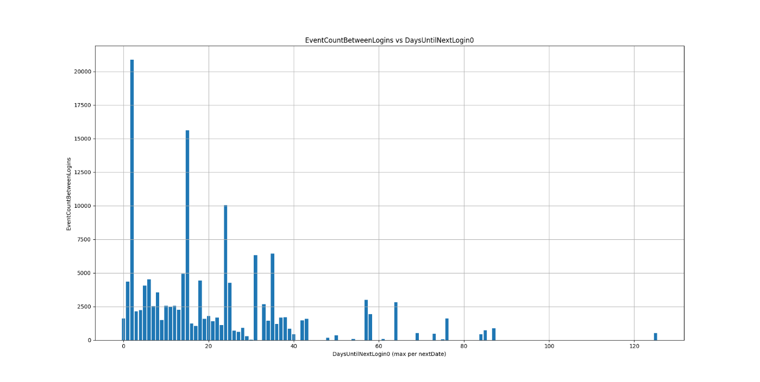
To better understand how the system behaves and how realistic the prediction task is, we plotted the distribution of days until the next service login (where a service login is identified by login logs with value 0) against the number of events that occur between the current service login and the next one. We then examined how prediction performance changes across these cases by analyzing the confusion matrix outcomes (TP, TN, FP, FN).
Figure 1 – Random Forest related Plot
Implemented Random Forest on 400k rows:
Accuracy: 76%
True Positives: 13%
True Negatives: 63%
False Positives: 11%
False Negatives: 12%
The plot at Figure1 visualizes the relationship between the number of events occurring between two login events and the number of days until the next login. Each bar represents how frequently a certain event count appears for a given time gap. We can see that most activity is concentrated at shorter time gaps, with a long tail extending to much larger intervals. This reflects the highly imbalanced and irregular nature of the operational behaviour captured in the logs.
This distribution is important because it shows why a single fixed threshold doesn’t work well. The same number of events can occur over very different time spans, and abnormal behavior isn’t always obvious or extreme – often it’s subtle and depends on the context (what the scanner was doing and when).
There are also substantial false positives and false negatives. This reflects the strong class imbalance and the difficulty of distinguishing early fault signatures from normal operational variability.
These results serve as an important baseline. They validate the feasibility of log-based fault prediction, but also motivate the need for more advanced temporal models and better handling of imbalance and early-warning behavior.

Planned Future Work
Next steps in the engineering process include:
- Refined Multimode Modeling
  - Improve mode segmentation and ensure that models are either mode-specific or mode-aware.
  - Introduce logic to differentiate between expected transitions (e.g., scan → reconstruction) and abnormal transitions.
- Advanced Feature Learning and Deep Models
  - Integrate convolutional kernel–based feature extraction and/or transformer-based models for more robust sequence modeling.
  - Optimize model architectures, training strategies, and hyperparameters to improve recall for rare fault types.
- Fleet-Level and Root-Cause Analytics
  - Develop statistical and explainable ML tools to identify recurrent causes across scanners (e.g., problematic software releases, certain environmental conditions).
  - Provide tools to connect predictions with underlying log patterns and service events.
- Architecture
  - Finalize architecture for ingestion, training, inference, and visualization.
  - Implement scheduled retraining, model versioning, monitoring, and rollback mechanisms.

Constraints and Challenges
A number of constraints shape the engineering process and strongly influence design choices, model selection, architecture, and the order in which features are developed. In addition, there are several practical challenges that make the project technically demanding.
- Working with Huge, Raw Log Datasets
The raw CT logs are large, noisy, and unstructured, making simple “load everything into memory and experiment” approaches impossible. Handling tens or hundreds of gigabytes of logs requires thinking in terms of streaming, chunking, and incremental processing instead of small, clean example files.
We will address this by designing the pipeline around batch/stream preprocessing, using efficient binary formats and indexes, and always prototyping on smaller samples before scaling up.
- Mapping and Normalizing Heterogeneous Logs
Logs from different CT models and software versions use different message formats, event codes, and naming conventions. A significant effort is required just to understand what each event means, group messages into templates, and build a consistent “log dictionary” that the models can rely on.
We plan to build a central mapping document and helper scripts that gradually standardize event codes, keep version-specific logic isolated, and allow us to update mappings incrementally as we discover new patterns.
- Aligning Logs with Failures and Service Records
To train predictive models, log windows must be aligned with real failures (from service tickets or maintenance records). This alignment is not trivial: a fault can develop gradually long before a ticket is opened, or a part is replaced. Determining which log intervals should be labelled as “pre-failure” is a complex and time-consuming step.
We will combine heuristic rules (time windows before known failures), automated joins on timestamps and scanner IDs, and selective manual review of borderline cases to incrementally improve label quality.
- Near-real-time requirements
To provide early alerts, which are advance warnings that indicate a high risk of failure before the failure actually occurs, the system must produce predictions quickly, which limits how heavy the models can be and how expensive feature extraction and deployment can become; we will address this by using incremental/streaming feature updates and latency-optimized models and serving (e.g., lightweight architectures, batching, and caching) to meet strict response-time targets.
- Rare failure events / class imbalance
Failures are rare compared to normal operation, causing strong class imbalance and making it harder to train reliable models that do not simply predict “no fault”. We will address this with cost-sensitive training (weighted losses), balanced sampling strategies, and decision-threshold tuning to keep high fault recall while controlling false alarms.
- Computational Load and Hardware Requirements
Feature extraction from large logs, training multiple model variants, and experimenting with deep learning architectures can easily exceed the capacity of a standard laptop. Some experiments may require powerful CPUs, large RAM, or GPUs, as well as careful optimization of code to avoid excessive runtimes.
We will mitigate this by starting with lightweight baseline models, optimizing preprocessing steps (vectorized operations, caching, reusing intermediate results), and, when needed, offloading heavy experiments to more powerful machines rather than trying to run everything locally.
- Balancing Model Complexity with Practicality
The challenge is to find a balance between advanced methods and models that are fast, stable, and interpretable enough to be useful for service engineers.
We plan to follow a staged approach: first establish strong, well-understood baselines (e.g., tree-based models), then introduce more complex sequence models only where they clearly add value and always compare against simpler alternatives.

The Product

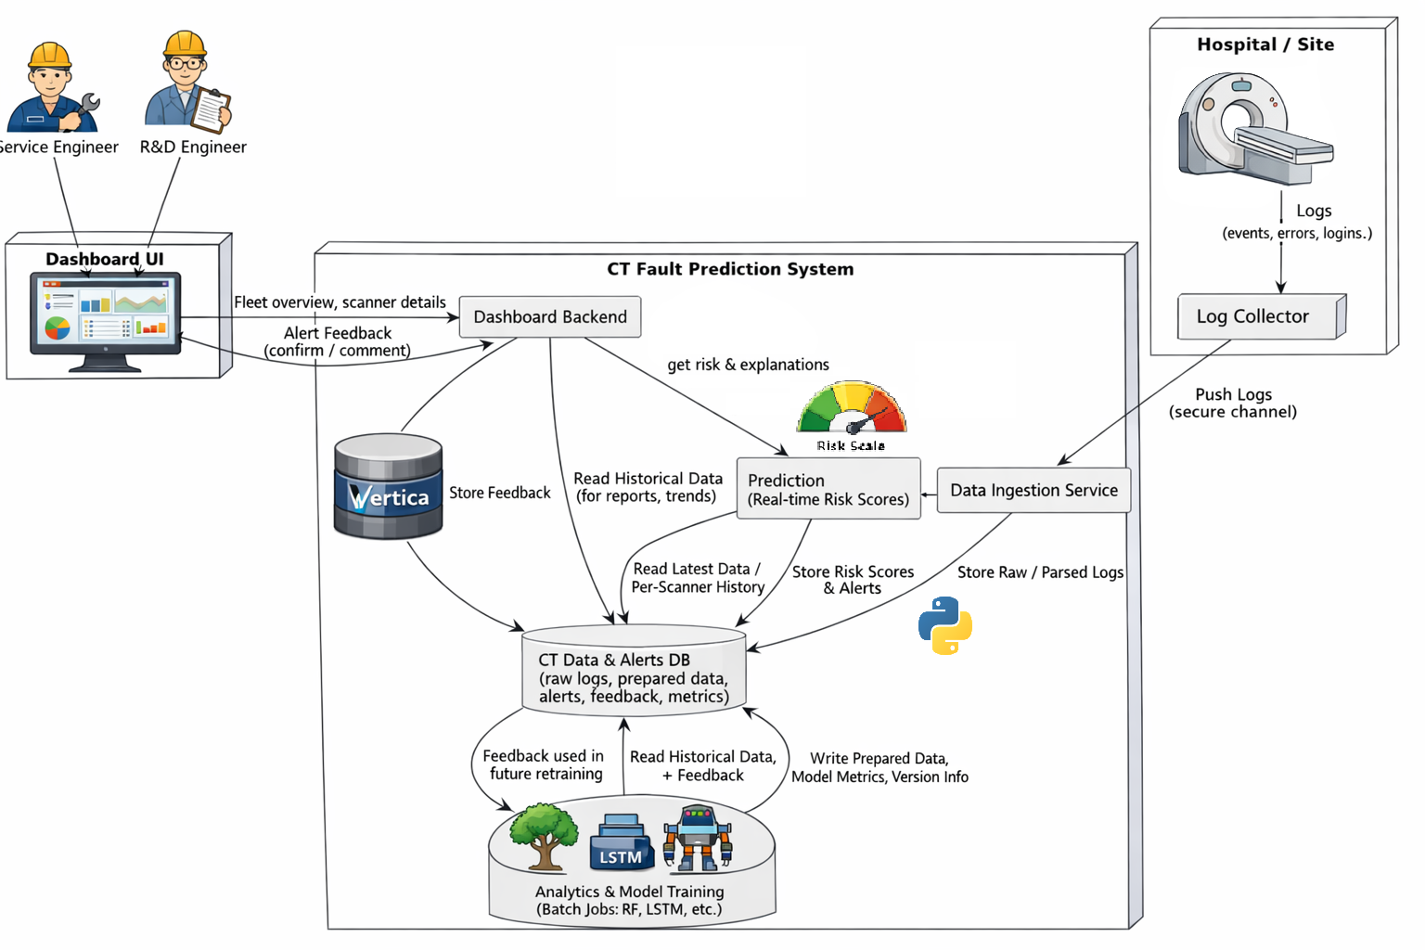
High level system architecture
Figure 2 – System Architecture
Hospital/Site: CT scanners + log collector.
CT Fault Prediction System:
Data Ingestion Service – receives and stores logs.
CT Data & Alerts DB – central database storing raw/parsed logs, prepared data, alerts, feedback, and metrics.
Analytics & Model Training – batch jobs that read data from the DB, prepare features/windows, train RF/LGBM/LSTM/Transformer models, and write model metadata back.
Prediction – uses models + data to compute risk scores and store alerts.
Dashboard Backend – server that talks to the Prediction and DB.
Frontend – shows fleet dashboards to Service Engineer and R&D Engineer.
There’s also a feedback loop: user feedback flows from frontend → backend → DB → training, so models can improve over time.

Algorithms and Models
This section describes the algorithms, models, and learning techniques used or planned in the CT fault prediction system.

Log Parsing and Template Extraction
- Parsing Logic
  - SQL queries extract logs from the database tables in csv format: logdb (scanner events, it’s attributes or names and values) , sn_pn (serial numbers and part numbers of scanner parts), system_errors (error massages), temperature, voltage, login, host_events (events from the host computer, not the scanner itself), calibration (all calibrations performed and it’s values) and additional tables may be added in the process as new logs are introduced and assessed as relevant.
  - Timestamps are normalized and converted to a unified format; scanner identifiers are mapped to a standard internal ID.
- Template Extraction
  - Similar messages are grouped into log templates.
  - Each template is assigned a unique template ID, creating a compact vocabulary of events for modeling.
- Sequence Building
  - Logs are segmented into fixed-length or variable-length windows (e.g., N days, K events, or “since previous service event”).
  - Each window becomes a training instance with a label indicating whether a failure occurred within a future horizon.

Feature Engineering and Time-Series Representation
- Statistical Features per Window
  - Frequency of each event and severity level.
  - Counts of specific error patterns (e.g., repeated cooling warnings, communication timeouts).
  - Temporal statistics (mean/variance of inter-event times, burstiness, trends over recent windows).
- Mode-Related Features
  - Dominant operating mode during the window (idle, scan, calibration, maintenance, etc.).
  - Number of mode transitions and unusual sequences of modes.
- History-Dependent Features
  - Time since last failure or service visit.
  - Number of minor warnings in the last X hours/days.
  - Cumulative event rates per subsystem (e.g., gantry, tube, cooling, software).
- Sequence Encodings for Deep Models
  - Convert event sequences into fixed-length embeddings – numeric vectors (similar to tokens in NLP).
  - Optional use of position encodings, segment IDs (per mode), or aggregated embeddings per time step.

Prediction Models
The system is envisioned as model-agnostic, supporting several families of algorithms:
- Baseline ML Models
  - Logistic Regression / Linear Models – simple baseline for global behavior.
  - Random Forests / Gradient Boosted Trees – strong performance on tabular features, robust to non-linear relationships and mixed feature types.
- Sequence and Deep Learning Models
  - LSTM / BiLSTM – capture temporal dependencies in ordered log sequences.
  - CNN-based models – detect local patterns and motifs in event sequences.
  - Transformer-based encoders – model long-range dependencies and complex interactions in logs, supporting attention-based interpretation.
- Anomaly Detection and One-Class Models
  - Models trained only on normal behavior (e.g., autoencoders or one-class SVM/SVDD) to detect deviations when labeled faults are scarce.
- Ensemble and Hybrid Approaches
  - Combine fast, interpretable tree-based models with deep sequence encoders to balance accuracy and explainability.
  - Mode-specific models or ensembles: one model per operating mode, plus a global aggregator.

Targets and Outputs
The primary prediction tasks are:
- Binary classification / Regression per window:
  - “Will a failure occur in the next T hours/days for this scanner?” (Yes/No).
  - “How many days until next failure?” (N days).
- Multi-class fault classification:
  - Predict the type of fault (e.g., cooling failure, motion failure, power/UPS issue, software exception).
- Risk scoring and ranking:
  - Continuous risk score in [0,1] used to rank scanners by urgency for preventive maintenance.

Data Structures
The system’s data structures are designed to support efficient training, prediction, and visualization.

Core Entities
- Log Event
  - Fields: EventDateTime, EventTypeName, EventName, AttributeName, AttributeValue, NumBad, Login, SystemError and additional fields may be added in the process as new log fields are introduced and assessed as relevant.
- Scanner Metadata
  - Fields: SystemCode, SerialNumber, model type, installation site, software version, configuration flags, environment attributes (if available).
- Service Event / Failure Record
  - Fields: fault description, parts replaced, severity, root cause (if known).
These entities are stored in SQL database and mirrored in files optimized for analytics and training pipelines.

User Interface – Conceptual Design
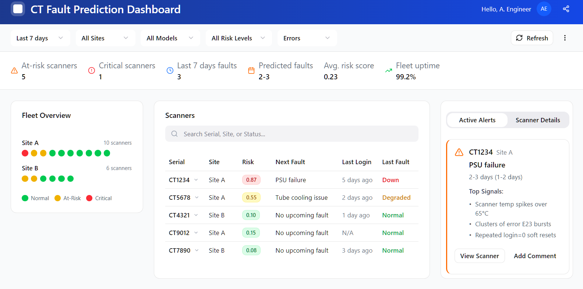
The user interface provides intuitive visualizations of scanner health and failure risk.
Figure 3 – Dashboard UI

Main Dashboard
- Fleet Overview Panel
  - List or grid of scanners with color-coded risk indicators (e.g., green/yellow/red).
  - Filters by site, model, and risk level.
  - Summary statistics: number of at-risk scanners, recent failures, average risk trend by site.
- Time-Series Risk View
  - For each scanner, a risk score over time alongside a timeline of key events and past failures.
  - Ability to zoom into periods of increasing risk and inspect underlying logs.
- Alerts and Recommendations
  - List of active alerts (scanner, risk, predicted horizon, suspected fault type).
  - Suggested actions.

Scanner Detail View
- Event Timeline
  - Chronological display of key log events, warnings, and mode transitions.
  - Highlighted segments where risk exceeded a threshold.
- Subsystem Health Panel
  - Per-subsystem indicators with recent error counts and trends.
- Explanation Panel
  - Feature importance or key patterns that contributed most to the current risk score (e.g., specific repeated warnings, unusual sequences).

Requirements

Functional
ID | Requirement
1 | The system shall ingest CT scanner logs from all connected scanners and normalize them into a unified schema.
2 | The system shall prepare training dataset from raw input data.
3 | The system shall build time windows for each scanner to be used by models.
4 | The system shall support training of multiple model types.
5 | The system shall evaluate models.
6 | The system shall generate alerts based on risk scores.
7 | The system shall provide a dashboard for: Fleet view, Scanner view.
8 | The system shall provide explanations for risk predictions.
9 | The system shall allow users to give feedback on alerts.
10 | The system shall monitor model performance over time and support retraining.
11 | Access to dashboard require authentication and authorization.

Non-functional
ID | Requirement
1 | The prediction API and dashboard should be available during normal working hours.
2 | Fleet overview and scanner details should be loaded within a reasonable time ≤ 5 seconds.
3 | The system must support growing numbers of scanners and logs.
4 | The system must provide logs and metrics for: Data ingestion status, Prediction performance and errors, Model performance and drift.
5 | The dashboard UI should be clear and intuitive.

Diagrams

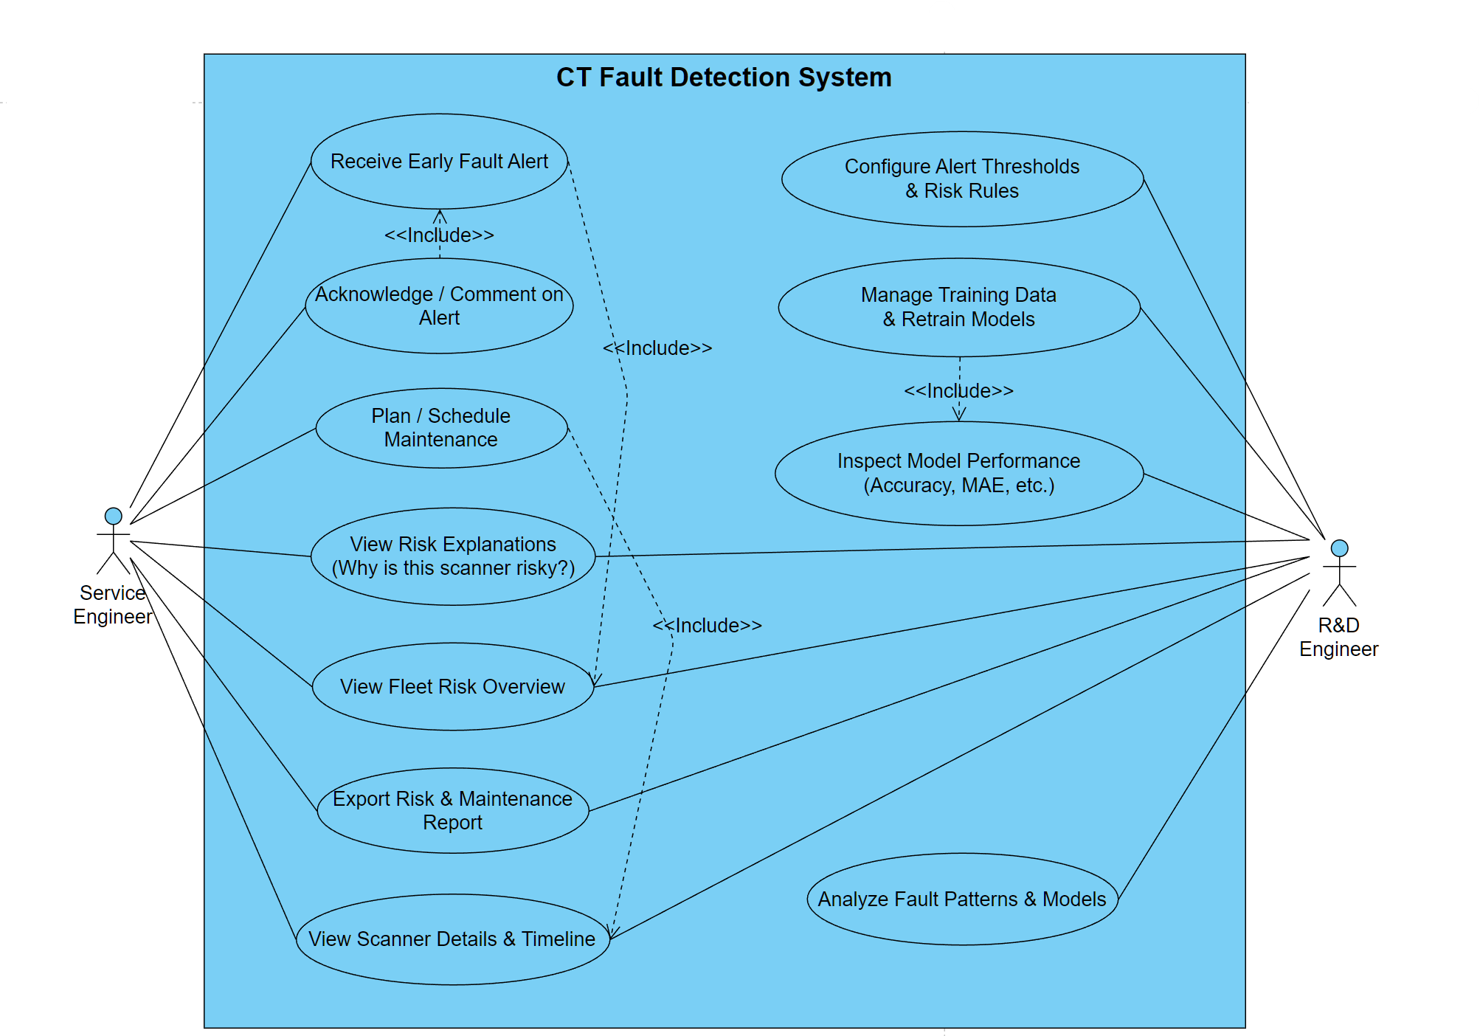
Use Case
Figure 4 – Use Case
This Use-Case diagram describes a CT Fault Detection System used by two main roles: a Service Engineer and an R&D Engineer.
The Service Engineer receives early fault alerts, reviews fleet and scanner risk (including explanations), schedules maintenance, and exports reports.
The R&D Engineer configures alert thresholds, manages training data, retrains models, and evaluates model performance to improve detection and analyze fault patterns.

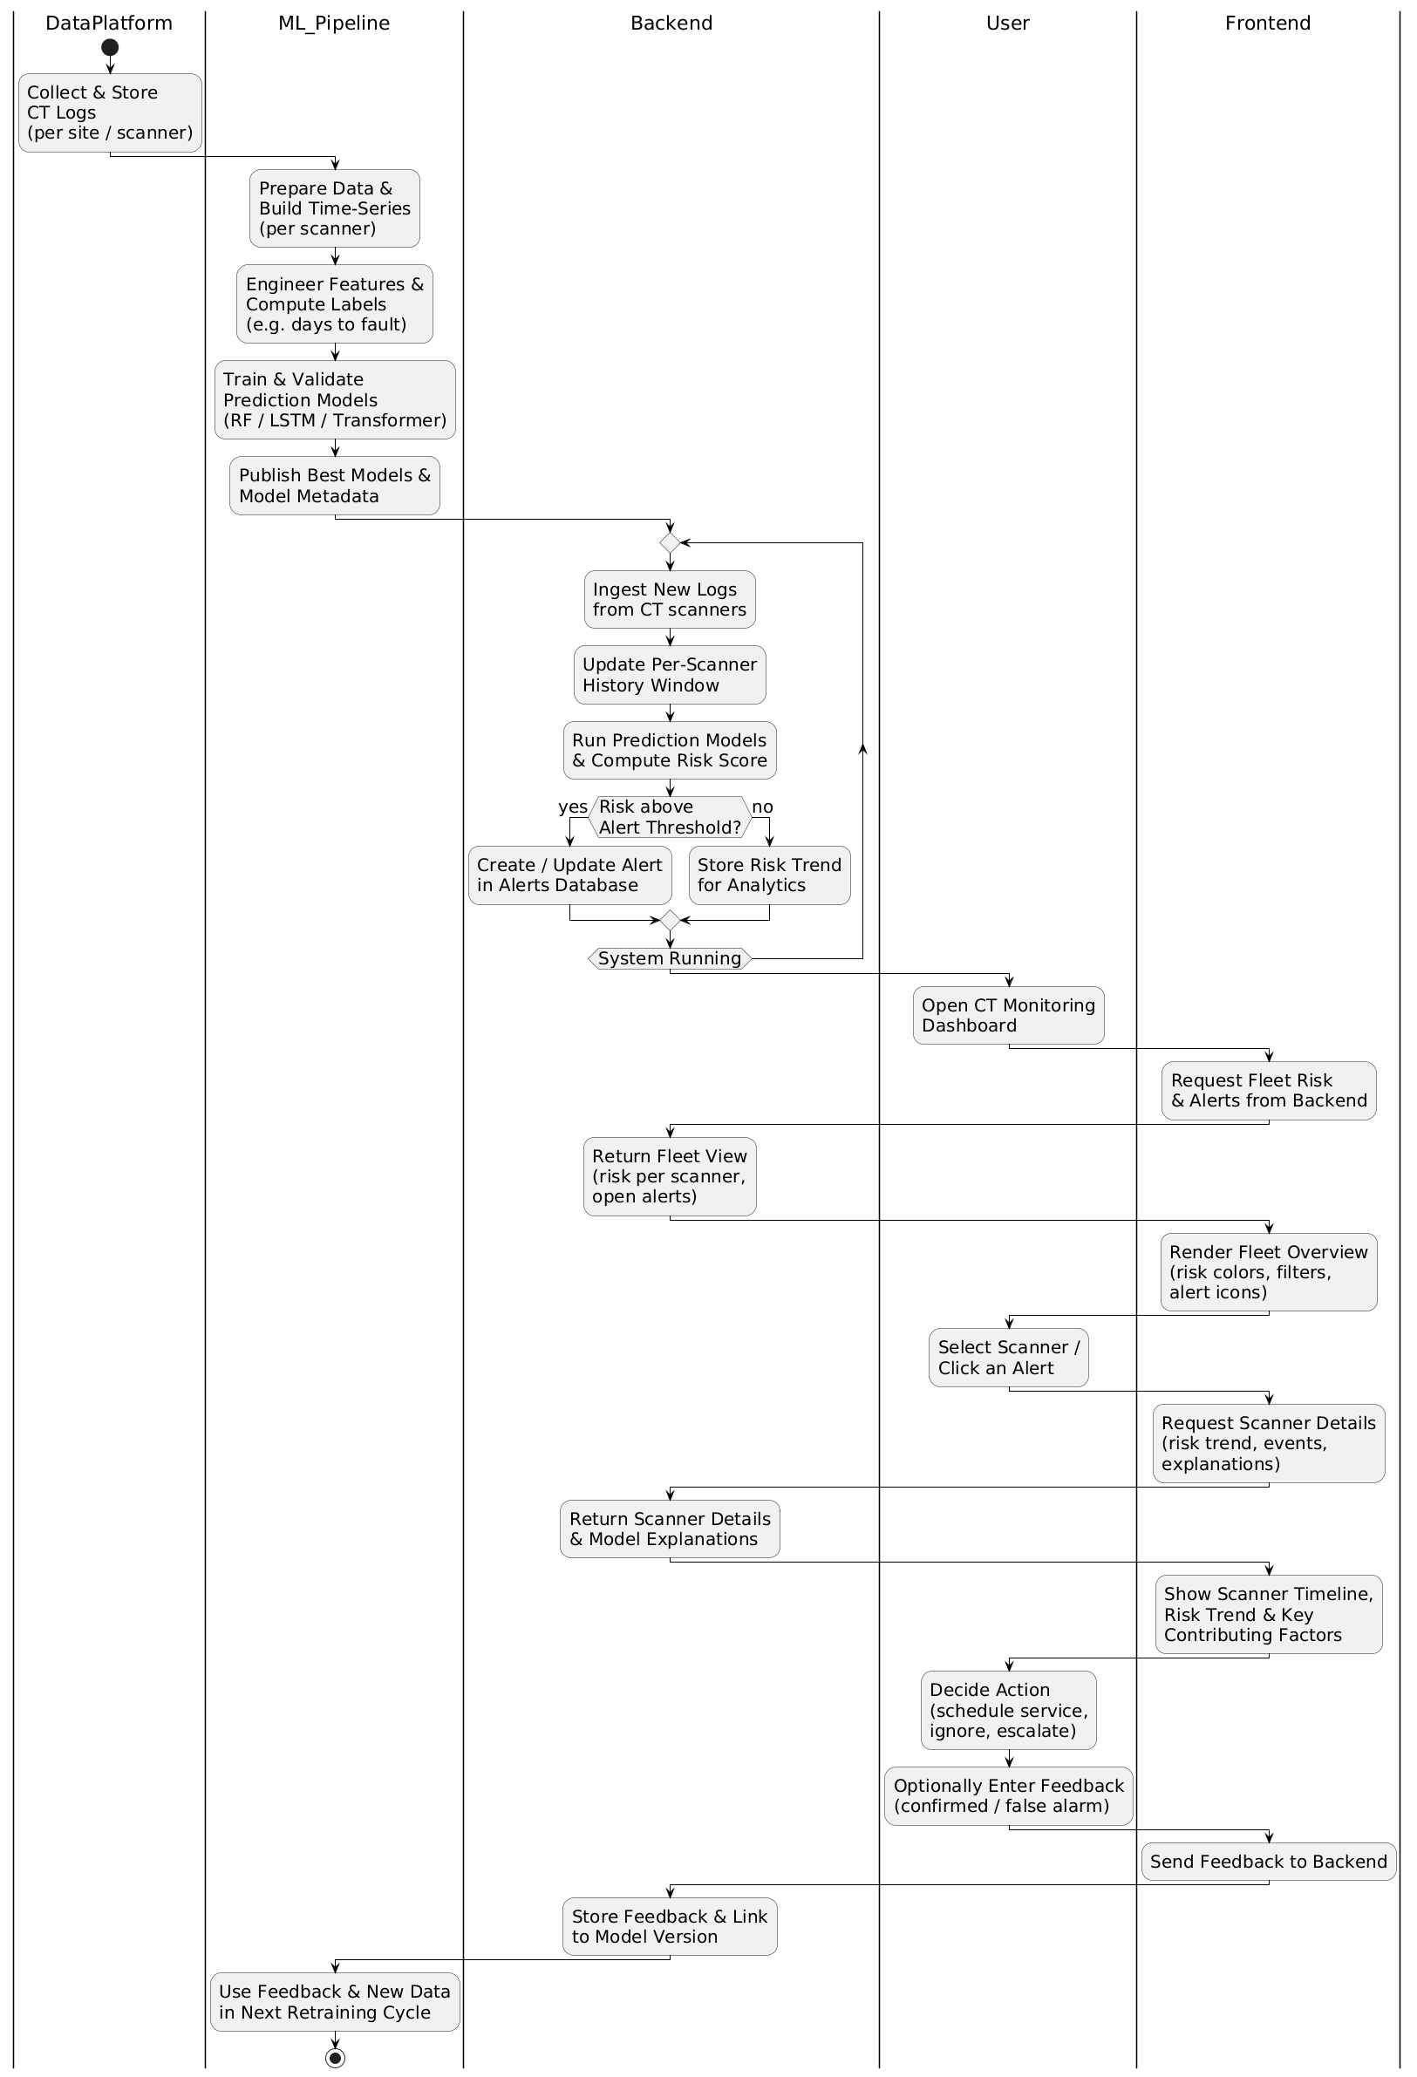
Backend Activity Diagram
Figure 5 – Backend Activity Diagram

The backend continuously ingests new CT scanner logs, updates each scanner’s history window, and then runs the published prediction models to compute a current risk score. It checks whether the risk exceeds the configured alert threshold: if yes, it creates/updates an alert in the alerts database; if not, it stores the risk trend for monitoring and analytics. This loop repeats as long as the system is running, enabling near-real-time fault risk detection.

Frontend Activity Diagram



Figure 6- Frontend Activity Diagram

This diagram is describing the frontend flow (how the UI behaves), with backend calls as supporting steps.
The user opens the CT monitoring dashboard, and the frontend requests fleet risk + alerts from the backend and renders the fleet overview (risk colours, filters, alert icons). When the user clicks a scanner or an alert, the frontend requests scanner details (risk trend, events, explanations) and then shows the scanner timeline and key contributing factors. Finally, the frontend supports the user decision (schedule service / ignore / escalate) and optionally collects feedback (confirmed vs false alarm) and sends that feedback back to the backend.

Verification and Evaluation

Verification
Verification ensures that the system is implemented correctly and that all components in the pipeline operate reliably before model evaluation is conducted.

ID | Verification Test Case | Method & Validation Procedure | Expected Result
1 | Log Ingestion Integrity | Load CT logs from Vertica from multiple scanners and time ranges, validate field mapping and schema compatibility. | Logs import successfully without corruption, timestamps and IDs preserved, malformed rows flagged or skipped without system crash.
2 | Preprocessing & Cleaning Pipeline | Test handling of missing values, duplicates, noise and out-of-order events. | Data is cleaned and standardized, missing values processed using defined strategies without breaking pipeline.
3 | Sequence Window Construction | Apply sliding/rolling windows to create sequences for prediction. | Windows generated consistently, event ordering preserved, sequence boundaries correct across datasets.
4 | Feature Extraction Validation | Validate computation of aggregated statistics, event counts, rolling features. | All features computed reproducibly, no dimension mismatch, feature vectors stored correctly.
5 | Model Training Execution | Run full training pipeline with fixed seed. | Model completes training without errors, checkpoints saved, repeated runs produce similar results (±2–5%).
6 | Integration Pipeline Test | End-to-end process: DB → Preprocessing → Model → Prediction → UI. | All components integrate correctly, data flows through the pipeline with no breakpoints.
7 | Robustness to Noisy/Partial Logs | Input logs with missing chunks, random noise or corrupted blocks. | System continues functioning, errors handled gracefully, warnings displayed instead of failure.
8 | Alert & Dashboard Output Verification | Run simulated test logs and check UI output. | Alerts displayed correctly with scanner ID, time window and risk score; no duplicated or missing alerts.

Evaluation
The following evaluation test cases measure the effectiveness, accuracy, robustness, and operational value of the proposed predictive maintenance model.
ID | Evaluation Test Case | Expected Result
1 | Measure failure prediction accuracy on unseen CT logs | The model correctly predicts ≥80% of upcoming failures (Recall ≥80%). Confusion matrix shows most failures classified correctly.
2 | Evaluate false alarm rate during normal operation across many scanner models | Precision ≥80% or False Alarm Rate ≤20%. Alerts during healthy operation remain minimal.
3 | Overall performance scoring (combined metric) | F1-Score ≥0.80, confirming balanced performance between precision and recall. No significant overfitting observed.
4 | Early-warning capability measurement | The model triggers alert at least one week prior to failure for most cases. Lead-time distribution is logged and analyzed.
5 | Robustness to log noise and data loss | System maintains stable operation when logs are missing or partially corrupted. Accuracy drop ≤10%. No crashes occur.
6 | Multi-class failure identification | The model correctly detects major failure categories with Recall ≥80% per class where data is available.
7 | Inference speed and scalability test | Inference latency <2 seconds per batch. Batch processing performance remains consistent under higher load.

Terms
Term | Detailed Explanation
CT | Computed Tomography is a medical imaging technology that uses X-rays and computer processing to create cross-sectional images of the body. Modern CT scanners are complex cyber-physical systems combining hardware, embedded control, reconstruction software, cooling systems, and calibration mechanisms. During operation, they continuously generate time-stamped operational logs that record system states, events, warnings, and errors.
Machine Learning | A field of artificial intelligence in which algorithms learn patterns from data instead of being explicitly programmed with rules. Machine learning models are used for tasks such as classification, regression, anomaly detection, and clustering.
Logs | Time-stamped textual or structured records generated automatically by systems to document events, states, warnings, errors, and operational activities. Logs are widely used for monitoring, troubleshooting, and predictive maintenance.
LSTM | Long Short-Term Memory - a type of recurrent neural network (RNN) designed to model sequential data while handling long-term dependencies. LSTMs use memory cells and gating mechanisms to decide what information to keep, forget, or output over time.
Transformers | A deep learning architecture designed for sequence modeling that relies on self-attention mechanisms rather than recurrence. Transformers can model long-range dependencies efficiently and are widely used in natural language processing and increasingly in time-series analysis.
Autoencoder | A neural network trained to reconstruct its input. It consists of an encoder that compresses data into a lower-dimensional representation and a decoder that reconstructs it. Autoencoders are commonly used for anomaly detection, dimensionality reduction, and representation learning.
Tree-based Classifiers | A family of machine learning models that use decision trees as their core structure. These models split data based on feature thresholds and are valued for interpretability and strong performance on structured/tabular data.
Random Forest | An ensemble learning method that builds many decision trees using random subsets of data and features. Predictions are made by aggregating the outputs of all trees, which improves robustness and reduces overfitting.
Gradient Boosting | An ensemble technique that builds trees sequentially, where each new tree focuses on correcting the errors of the previous ones. It often achieves high predictive performance in structured data problems.
SVM | Support Vector Machine - a supervised learning algorithm used for classification and regression. It finds an optimal boundary (hyperplane) that maximizes the margin between different classes in the feature space.
Clustering Methods | Unsupervised learning techniques that group similar data points together without labeled outputs. Examples include K-Means and DBSCAN. These methods are often used for pattern discovery or anomaly detection.
SMART | Self-Monitoring, Analysis and Reporting Technology - a monitoring system originally developed for hard drives and storage devices that tracks health indicators and predicts failures. In research literature, SMART data is often used as an example of log-based predictive maintenance.
CNN | Convolutional Neural Network - a deep learning model that uses convolutional layers to automatically extract spatial or local patterns. CNNs are widely used in image processing and can also be applied to time-series and signal data.
PLC | Programmable Logic Controller - an industrial digital computer used to control manufacturing processes, machinery, and automation systems in real time. PLC-controlled systems often generate event logs and status data used for fault detection.
ROCKET | Random Convolutional Kernel Transform - a fast and efficient method for time-series classification that transforms signals using a large number of random convolutional kernels and then applies a linear classifier.
MiniROCKET | An optimized and more computationally efficient version of ROCKET that uses a deterministic set of convolutional kernels for faster feature extraction.
HYDRA | A time-series classification approach that extends random convolutional kernel ideas with multiple transformations, improving performance on complex temporal patterns.
BiLSTM | Bidirectional LSTM - a variation of LSTM that processes sequences in both forward and backward directions. This allows the model to learn from both past and future context within a sequence.
Remaining Useful Life | An estimate of the time remaining before a component or system is expected to fail. RUL prediction is a central task in predictive maintenance.
RESTful APIs | Application Programming Interfaces that follow REST (Representational State Transfer) principles and use HTTP methods (GET, POST, PUT, DELETE) to enable communication between systems over a network.
CRISP-DM | Cross-Industry Standard Process for Data Mining - a widely used framework for data science projects that includes six phases: business understanding, data understanding, data preparation, modeling, evaluation, and deployment.
Agile Approach | A software development methodology based on iterative development, short cycles (sprints), continuous feedback, and flexibility to adapt to changing requirements.
Accuracy | A performance metric measuring the proportion of correct predictions out of all predictions. It can be misleading in highly imbalanced datasets.
Precision | The proportion of predicted positive cases that are actually positive. High precision means few false alarms.
Recall | The proportion of actual positive cases that are correctly identified. High recall means few missed failures.
F1 Score | The harmonic mean of precision and recall. It provides a balanced measure when both false positives and false negatives are important.
CPU | Central Processing Unit - The main processor of a computer responsible for general-purpose computations. Suitable for sequential and control-heavy tasks.
RAM | Random Access Memory - Volatile memory used to temporarily store data that programs actively use. Large RAM is critical when processing high-volume log or time-series data.
GPU | Graphics Processing Unit -A processor specialized for parallel computation. GPUs significantly accelerate deep learning training and large matrix operations.
Tokens in NLP | The basic units of text processed by language models. Tokens can be whole words, subwords, or characters depending on the tokenization method.
SVDD | Support Vector Data Description -An anomaly detection method that learns a boundary around normal data in feature space. Points outside this boundary are considered anomalies.
MAE | Mean Absolute Error - A regression evaluation metric measuring the average absolute difference between predicted and true values.
ROC-AUC | Receiver Operating Characteristic - Area Under Curve – a metric that measures a model’s ability to distinguish between classes across all classification thresholds. A higher AUC indicates better separability.

References
[1] Shen, J., Wan, J., Lim, S.-J., & Yu, L. (2018). Random-forest-based failure prediction for hard disk drives (Part-Voting Random Forest). International Journal of Distributed Sensor Networks, 14(11), 1550147718806480. https://doi.org/10.1177/1550147718806480
[2] Hadadi, F., Dawes, J. H., Shin, D., Bianculli, D., & Briand, L. (2024). Systematic evaluation of deep learning models for log-based failure prediction. Empirical Software Engineering, 29(5), 105. https://doi.org/10.1007/s10664-024-10501-4
[3] Vargas, V. M., Rosati, R., Hervás-Martínez, C., Mancini, A., Romeo, L., & Gutiérrez, P. A. (2023). A hybrid feature learning approach based on convolutional kernels for ATM fault prediction using event-log data. Engineering Applications of Artificial Intelligence, 123, 106463. https://www.sciencedirect.com/science/article/pii/S0952197623006474
[4] Zhou, X., [Author(s) not fully available] (2024). Predictive maintenance model for CT equipment. ScienceDirect (abstract). https://www.sciencedirect.com/science/article/abs/pii/S0933365724000496
[5] Pomšár, L., Tsvietaieva, M., Krupáš, M., & Zolotová, I. (2025). AI-based CT X-Ray tube failure classification. Applied Sciences, 15(12), 6547. https://doi.org/10.3390/app15126547

